
LESSON NOTE | DETAILED EXPLANATORY NOTES
ECOLOGY & EVOLUTION
ADAPTATIONS OF ORGANISMS
GRADE 12 - BIOLOGY
■ ■ ■

Fitting the Environment
An adaptation is any feature of an organism that helps it survive and reproduce in its environment. Living things are remarkably well suited to where they live - a desert plant that stores water, a snake that makes venom, birds that migrate before winter. Each of these is an adaptation, developed over many generations through natural selection. Adaptations can be grouped into three kinds: morphological (body structure), physiological (internal processes) and behavioral (the way an organism acts).
This lesson explains the three types of adaptation with examples, shows how adaptations help organisms survive, and links them to natural selection. It is a key idea in the Ecology & Evolution strand and prepares for later lessons on evolution.
Why This Matters
- Adaptations explain how organisms survive in their habitats.
- They show the link between structure and function.
- They are the visible result of evolution and natural selection.
- They help explain the huge biodiversity of life, including in PNG.
Adaptations of Organisms
Key Learning Outcomes
By the end of this lesson, students should be able to:
- Define an adaptation and explain its purpose.
- Describe the three types: morphological, physiological and behavioral.
- Give examples of each type of adaptation.
- Explain how adaptations improve survival and reproduction.
- Link adaptations to natural selection.
The Three Types of Adaptation
Adaptations are grouped by what they change. Morphological adaptations are features of an organism's structure or shape - such as sharp claws, a long beak, thick fur, or camouflage coloring. Physiological adaptations are internal chemical or process changes - such as producing venom, conserving water, sweating to cool down, or making antifreeze proteins. Behavioral adaptations are the ways an organism acts - such as migrating, hibernating, hunting in a group, or being active at night. Many organisms combine all three.
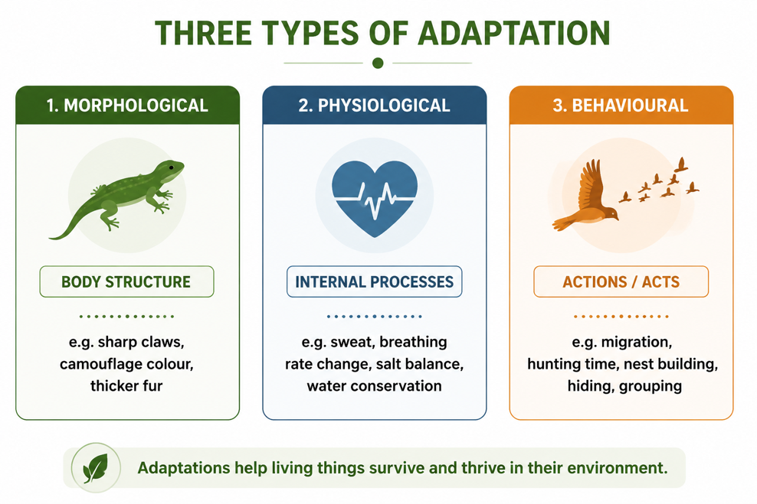
Figure 1: The three types of adaptation - morphological (structure), physiological (processes) and behavioural (actions).
Terminologies and Concepts
Useful terms for this topic:
- Adaptation: a feature that helps an organism survive and reproduce.
- Morphological adaptation: a feature of body structure or shape.
- Physiological adaptation: an internal process or chemical adaptation.
- Behavioral adaptation: an inherited pattern of behavior.
- Habitat: the place where an organism lives.
- Natural selection: the process by which helpful features become more common.
- Survival advantage: a feature that improves the chance of surviving and breeding.
Examples of Adaptation
Adaptations are everywhere in nature. Camouflage - such as a stick insect that looks like a twig - is a morphological adaptation that hides an animal from predators. A snake's venom is a physiological adaptation for catching prey and defense. Migration - birds travelling long distances to find food - is a behavioral adaptation. Plants show them too: waxy leaves and deep roots help them survive drought, and being nocturnal helps some animals avoid the heat of the day. In every case, the feature improves the organism's chance of survival in its particular environment.
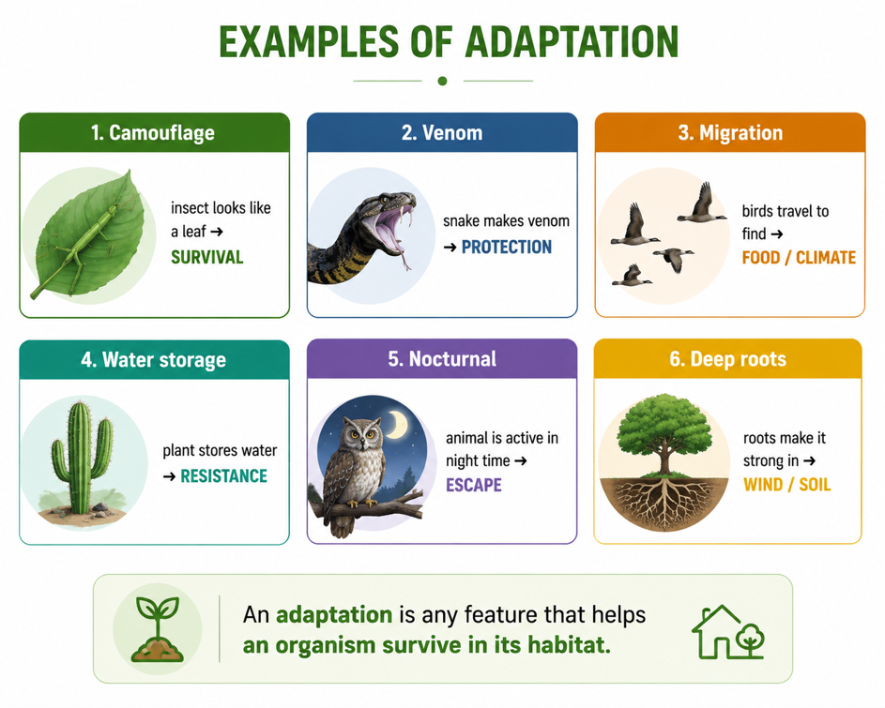
Figure 2: Examples of adaptation across animals and plants, each suited to its environment.
Why Adaptations Matter - The Link to Survival
Adaptations are important because they give an organism a survival advantage. An organism that is well adapted is more likely to find food, avoid predators, cope with the climate, and therefore survive long enough to reproduce. Because many adaptations are inherited, well-adapted parents pass their helpful features to their offspring. Over many generations, this process - natural selection - makes useful adaptations more common in a population. In this way, the environment gradually 'shapes' the organisms that live in it.
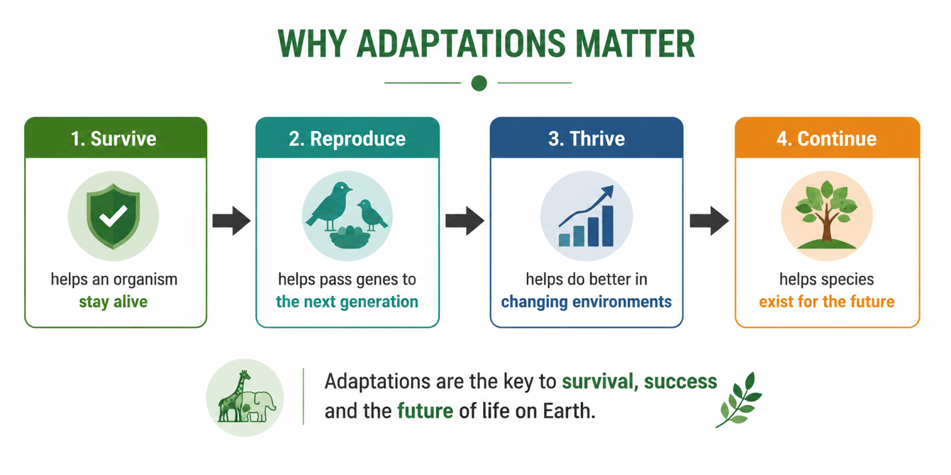
Figure 3: Adaptations improve survival and reproduction, and are passed on and shaped by natural selection.
Adaptation and Natural Selection
Adaptations do not appear because an organism 'wants' or 'tries' to change. They arise because individuals in a population naturally vary - some, by chance, have features better suited to the environment. These better-suited individuals are more likely to survive and reproduce, so their helpful features are passed on and become more common over generations. What looks like a perfectly designed adaptation is really the result of variation and natural selection acting over a very long time - the central idea explored in the evolution lessons.
Why This Matters
- Survival - adaptations are the key to how organisms fit their environment.
- Biodiversity - different adaptations produce the huge variety of living things.
- Evolution - adaptations are the visible evidence of natural selection.
- Conservation - knowing species' adaptations helps us protect their habitats.
PNG Context Example
Papua New Guinea is one of the most biodiverse places on Earth, full of striking adaptations. The birds of paradise have spectacular plumage and courtship dances (morphological and behavioral adaptations for attracting mates). Mangrove trees have special roots and salt-handling processes (morphological and physiological) that let them live in salty coastal mud. Many rainforest insects use camouflage to hide, and tree kangaroos are adapted for climbing. Studying these local examples helps PNG students understand adaptation directly and highlights why protecting the country's unique habitats and biodiversity is so important.
References & Related Documents
Source Documents
- Biology Standards-Based Syllabus, Grades 11 & 12 (PNG SBC 2020) - Strand: Ecology & Evolution; investigate how organisms are adapted to their environment (structural, physiological and behavioral adaptations).
- STEM Biology Syllabus - Grade 12. Thema: Ecology & Evolution; Module: Adaptation and Survival. Department of Education, PNG.
Further Reading & References
- OpenStax Biology - Adaptation; Natural Selection and Adaptation. https://openstax.org/books/biology
- Khan Academy - Adaptation and the environment. https://www.khanacademy.org/science/biology/ecology

